**FINANCIAL CRISIS IN 2008 AFFECTED THE INVESTMENT RETURN.**

*A random walk down Dow Jones Industrial Average. 2000-2020.*

As person interested in investment, especially Stock Markets, I wanted to answer if despite the financial crisis is a good idea to invest in stocks. With no clear future where we cannot ensure receiving public pension plan in our retirement. Or even because you are pursuing the financial independence, this article might spawn your interest.

Why Dow Jones Industrial Average (DJI) or simply Dow 30?

Dow Jones is the second-oldest index among the U.S. market indices, after the Dow Jones Transportation Average. Created by Charles Dow on May 26, 1896, DJI measures the stock performance of 30 large companies listed on stock exchanges in the United States.

Dow Jones Industrial, as index, is calculated by the sum of stock prices of the 30 companies included in the index, divided by a factor which is currently approximately 0.152; but constantly changing.

At the beginning, DJI was created as “industrial”, but certainly it makes no reference nowadays thanks to the boom of the financial and technological companies as we are going to analyse below.

I figured out appropriate to split the index in 9 main sectors presented in the index. The sectors are:

* Aerospace: Boeing.
* Conglomerate: 3M, Honeywell.
* Construction: Caterpillar, Chevron, Dow.
* Consumer goods: Coca-Cola, McDonald’s, Procter & Gamble.
* Entertainment: Disney.
* Finance: American Express, Goldman Sachs, JP Morgan, The Travelers Companies, Visa.
* Pharma: Amgen, Johnson & Johnson, Merck, UnitedHealth Group.
* Retail: The Home Depot, Nike, Walgreens, Walmart.
* Tech: Apple, Cisco, IBM, Intel, Microsoft, Salesforce, Verizon.

After Bloomberg platform, probably Yahoo finance is one of the best free tools to analyse companies listed in any stock market. Then, after a brief investigation, I found a fantastic simple library to download and then create any data from yahoo finance.

And the process would be the following:

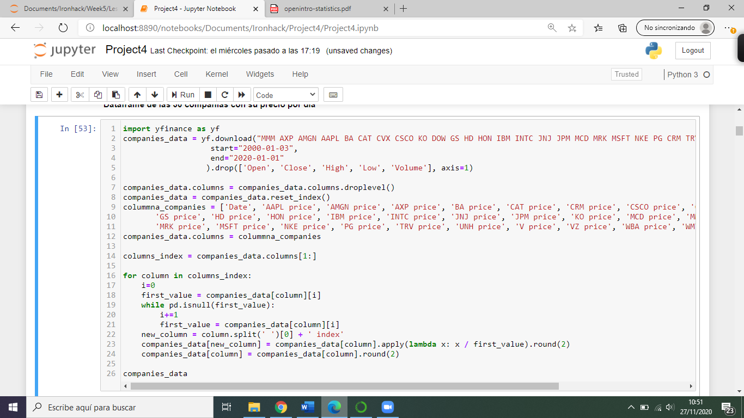

In the above image we can observe that we removed some columns (Open, Close, Low and Volume) because of not being of our interest for the analysis. In addition, we might reset the index, that will be “Date” in this case, and modify the names of the columns. Finally, we created a new column for each company called “Index”. The “Index” will calculate the total return from each company taking in consideration the “Date”. Other detail would be to round the number in only 2 decimals.

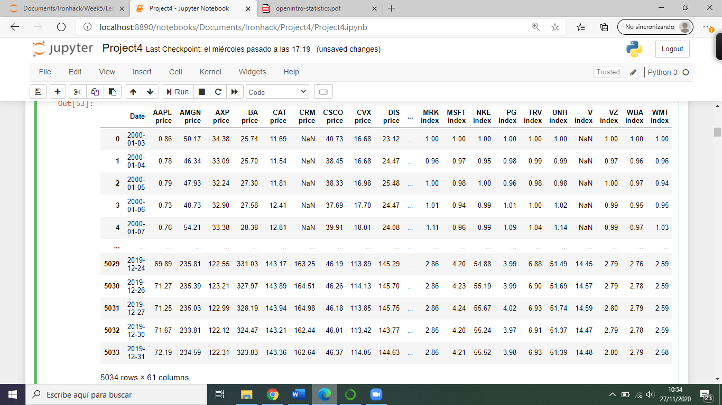And we got the dataset:

From the main dataset is the moment to start the analysis.

The first step was to classify the 30 companies from the dataset in 9 groups as the 9 industries listed in Dow Jones. After classifying the companies, we added a new column called “Result index”. “Result index” is the sum of the index from each day of the companies in that sector, divided by the number of companies in the sector. For example:

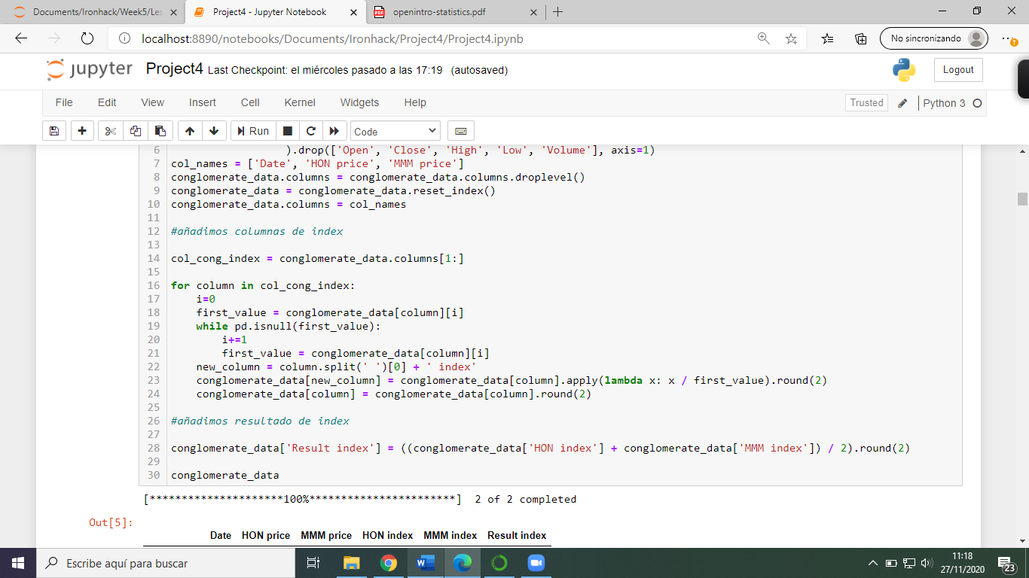

Thanks to that action, the result will be as below for the 9 sectors:

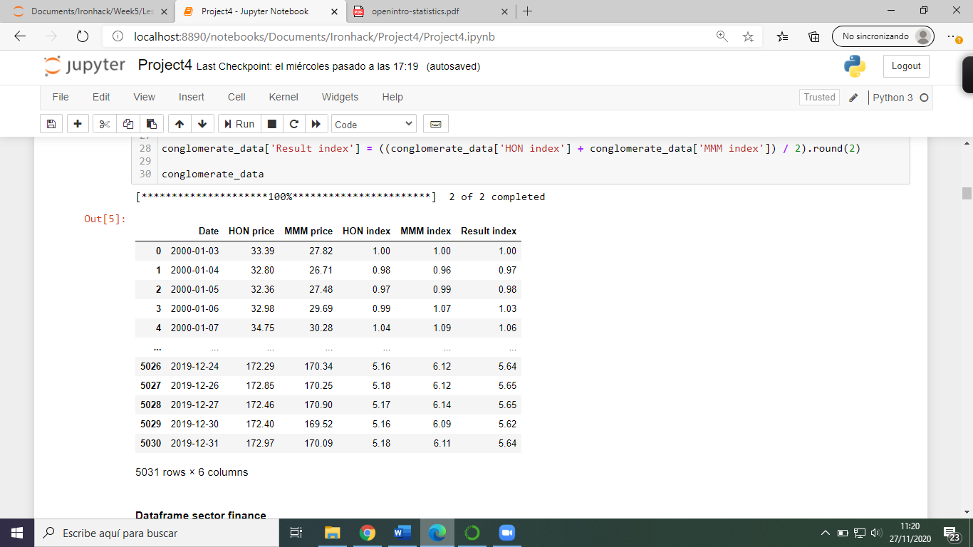

In this case, the conglomerate sector has been revaluated by 5.64 in last 20 years.

Once, we got the Result index from all sectors, we compared the 9 different Result indexes to answer which sector has had more revaluation in last 20 years.

We have decided to work with “matplot” in order to create the graph. We defined the columns that we wanted to show, the size of the graph, the titles, the colors and the legend represented with each sector:

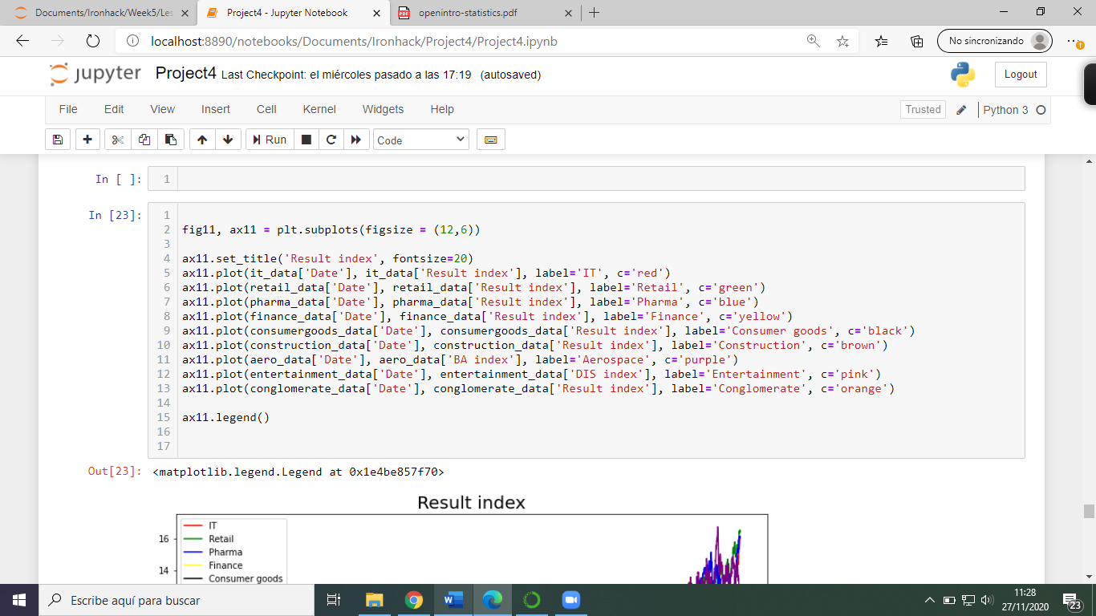

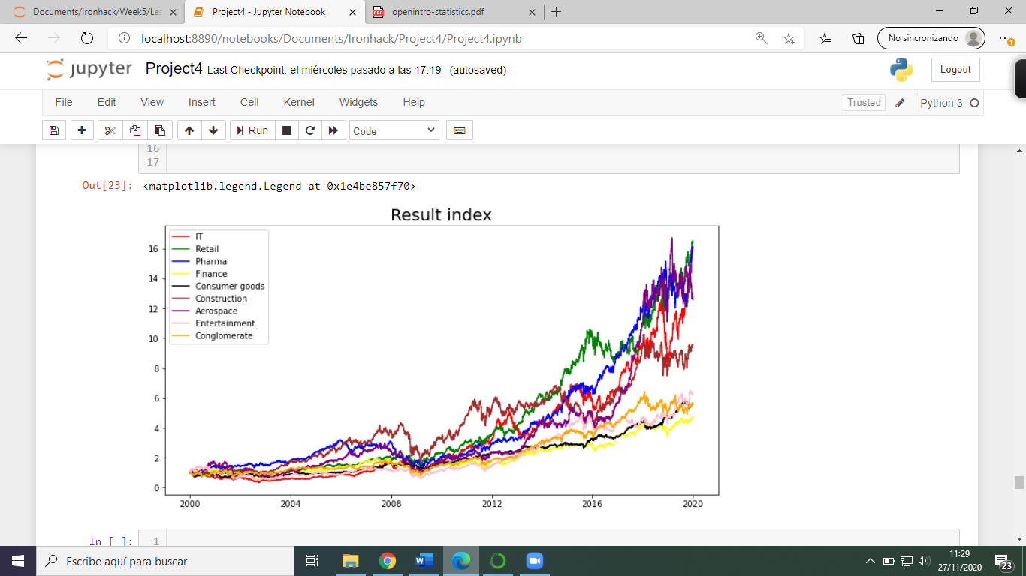The graph was shown like this:

Our first conclusion that we can observe in the results is that there are 3 different groups regarding the revaluation. The first group is composed by IT, Retail, Pharma and Aerospace. The second group, in the middle, is only Construction. And the third group with less revaluation is composed by Consumer goods, Entertainment, Conglomerate and Finance.

Taking in consideration these results, we tried to answer the second question. What is the company with a higher revaluation per share in last 20 years. In order words, if you wanted to invest 1 dollar in 2000, in which company from DJI would be more profitable after 20 years.

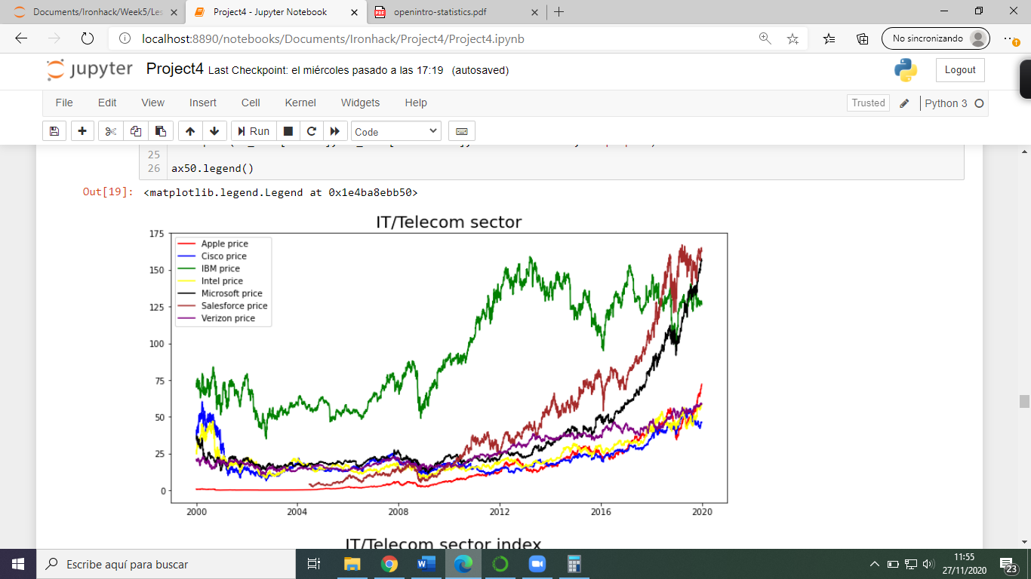After evaluating all sectors, we realized that the question will be solved in the IT/Tech sector. From one side we are going to show the price per share and on the other, the revaluation per share.

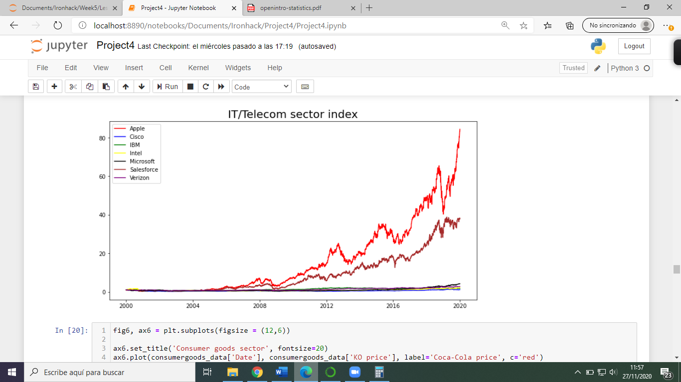

Did you notice the difference?

When we talk about investment return, it does not mind to pay attention on price per share, but revaluation. If we only paid attention in price per share, we would think that Microsoft would be the best investment. On the other hand, in terms of revaluation per share, the number one has been Apple. Said in order words, if our dream is to become millionaire, investing in 2000 in Microsoft we would need 237,529.7$ from the start. However, we would only need 11,845.5$ of Apple shares. Around 20 times less to get the same.

In this point of the analysis, we already have to answer the main hypothesis. For that, first of all we download a dataset called “DJI_data”. We removed the columns that we are not interested for our analysis as we did before and also, we added a new column called “Daily return %” through *pct_change*.

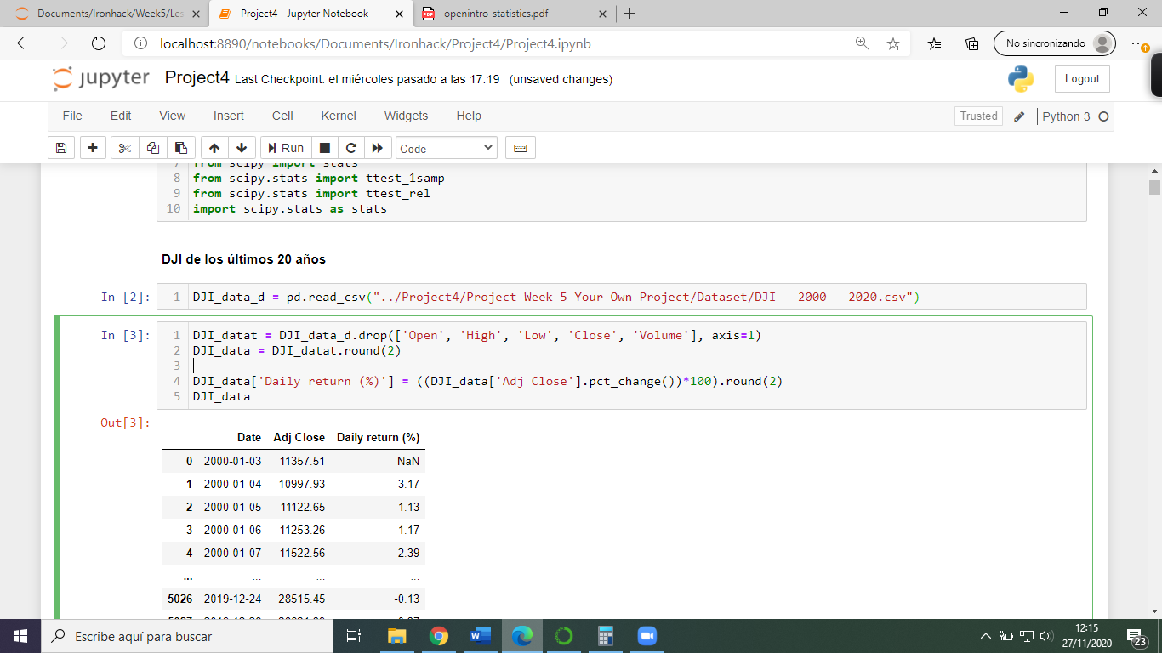

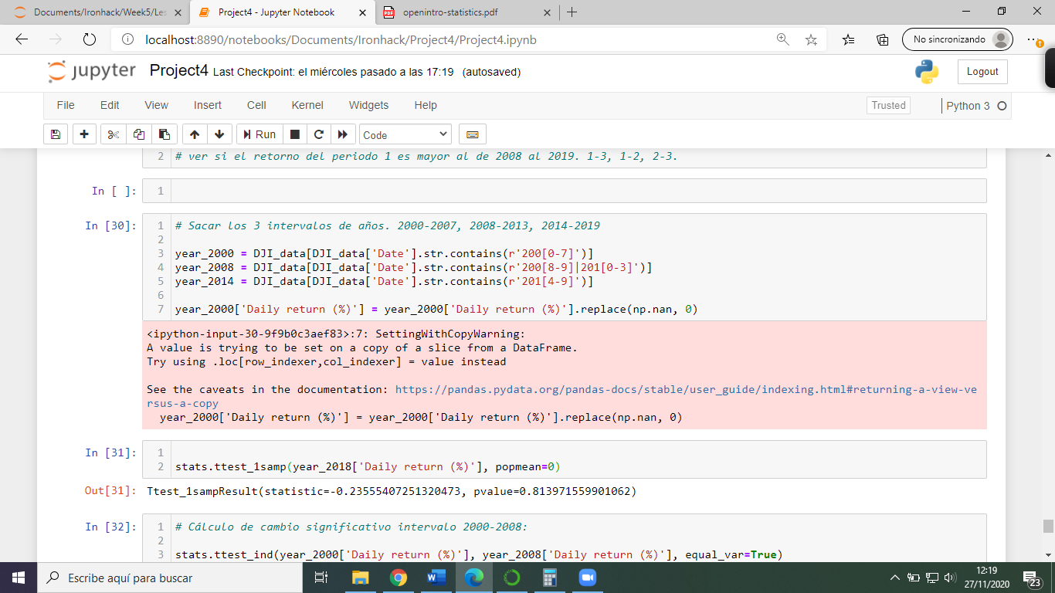Once we added the column, we classified the 20 years in 3 intervals: 2000-2007, 2008-2013 and 2014-2019. Then, we could observe if the financial crisis affected to the investment return in long period.

Last step before to conclude the hypothesis, we would have to extract the “p-value” to check if the difference is significantly relevant or not.

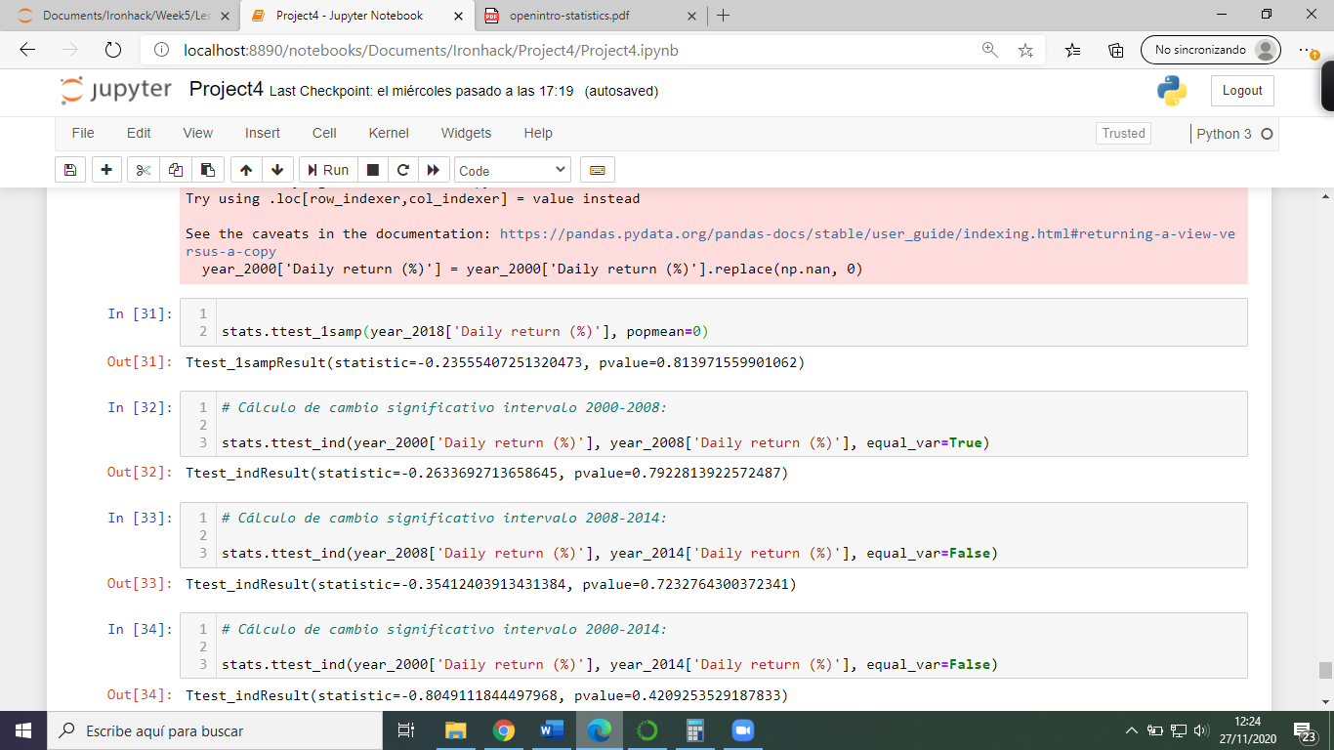We made three comparisons with the three intervals that we classified. For the three comparisons will be the following code just switching the variables to compare:

And this gives us three results:

* p-value1: interval 1 and interval 2 -> 0.79228*
* p-value2: interval 2 and interval 3 -> 0.72327
* p-value3: interval 1 and interval 3 -> 0.42092

*For a significant difference should be p-value < 0.05

To emphasize the conclusion of our hypothesis, we also calculated the Daily return in % in the three intervals independently. Therefore, we can observe that the difference is not big enough to say that one period of time was much more profitable than other.

* Daily return interval 1: 0.0135%
* Daily return interval 2: 0.0245%
* Daily return interval 3: 0.0393%

As it is observed, despite of the financial crisis produced in 2008, interval 2, the daily return was in line with the other two intervals. This fact along with the p-value measure shows us that the investment return was not significantly affected comparing the other two intervals.